**📌 Excel Dashboard Project Fill-Up Document**

### **Project Overview**

This project requires interns to create an interactive Excel dashboard based on a your dataset. The dashboard should provide key insights, be well-structured, and include interactivity features such as slicers and PivotTables.

The entire project must be completed within **1.5 days** following the structured timeline below.

## **🕒 Project Task Breakdown**

### **📅 Understanding & Data Preparation**

#### **✅ Task 1: Project Brief & Requirement Understanding**

* **Describe the business case in 2-3 sentences:**
* The dataset consists of 17,686 rows and 16 columns, representing simulated phone usage data of Indian users. Each row corresponds to an individual's mobile usage details, phone brand preferences, daily screen time, and app usage patterns.
* **Key metrics and objectives identified:**
* **Key metrics such as Demogaphic insights, Phone brand preference,Daily screen time, App usage pattern, App usage pattern, User Segmentation**
* **Objectives are we can uderstand user behaviour , Brand preference analysis and Marketing Taget**
* 📌 **Deliverable:** Project understanding summary (in the space above, you can take up more space if needed.

#### **✅ Task 2: Data Cleaning & Preparation**

* **Describe the steps taken for data cleaning in excel and powerquery (missing values, duplicates, formatting, new columns etc):**
* Remove unwanted column (User ID).
* Corrected the os structure (Apple – ios, Realme, nokia , vivo – Android).
* Create a new column Age catogory use in condition column.

<https://github.com/aslam070/Excel-Task-/blob/main/Phone%20usage%20of%20india%20submitted%20by%20Aslam.xlsx>

* **List the separate sheets created (e.g., Raw Data, Cleaned Data):**
* 📌 **Deliverable:** Cleaned dataset (Excel file with two sheets: Raw Data & Cleaned Data).

### **📅 Dashboard Development**

#### **✅ Task 3: Exploratory Data Analysis**

* **Summary of key insights derived from data analysis:**
* **Demographic Insights** – Age, gender, and location distribution of users.
* **Phone Brand Preferences** – Most popular phone brands among users.
* **Daily Screen Time** – Average time spent on mobile devices.
* **App Usage Patterns** – Most frequently used apps and their usage duration.
* **User Segmentation** – Clustering users based on usage behavior.
* **Formulas used (SUMIFS, COUNTIFS, AVERAGE, etc.):**
* 📌 **Deliverable:** Summary table in an Excel sheet.

#### **✅ Task 4: Dashboard Wireframing**

* **Sketch or describe the planned dashboard layout ( Use design tools like figma, mockup Ai, or draw,take a snap and paste ):**
* 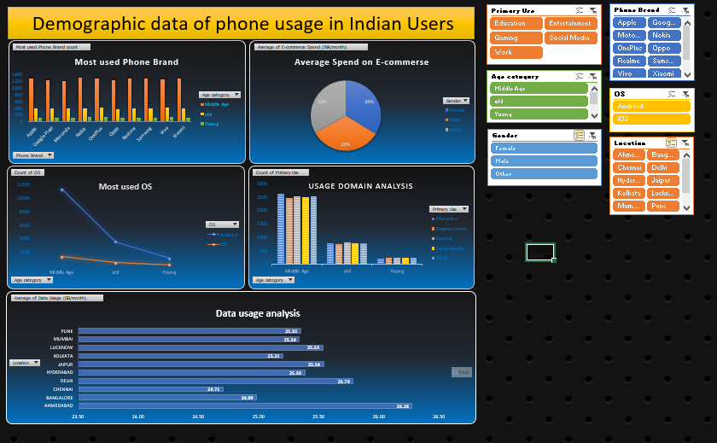

#### **✅ Task 5: Dashboard Creation**

* **List of PivotTables, PivotCharts, slicers, and dropdowns used:**
* **List of Pivot Tables -Count of OS,** **Most used Phone Brand count,** **Count of Primary Use, Average of Spend on E-commerse.**
* List of Pivort chart-**Most used Phone Brand (Clustered column), Average of Spend on E-commerse(Pie chart), Most used OS(Line chart),** **count of primay use(Clustered column).**
* 📌 **Deliverable:** Fully functional dashboard (Excel file).

### **📅 Presentation**

## **📎 Submission Checklist**

✔ **Excel Dashboard File** (Interactive with slicers & charts)  
 ✔ **Cleaned Data File** (Separate sheet for raw & cleaned data)  
 ✔ **Documentation Report** (Summary of steps, formulas, insights)  
 ✔ **Presentation Slides** (Optional, 3-5 slides summarizing key points)

**📢 Notes:**

* Ensure a **structured approach** (separate sheets for raw data, cleaned data, dashboard).
* Maintain **formula integrity** (avoid hardcoded values).
* Use **professional formatting** (consistent fonts, color coding, and spacing).
* Keep the dashboard **dynamic & interactive** for better usability.

📌 **Deadline:** [27/2/2025 3 pm]

This structured document ensures that interns follow a professional workflow and provide clear, step-by-step updates on their work. 🎯